## CSS3 Transitions

CSS3 transitions allows you to change property values smoothly (from one value to another), over a given duration.

## Browser Support for Transitions

The numbers in the table specify the first browser version that fully supports the property.

Numbers followed by -webkit-, -moz-, or -o- specify the first version that worked with a prefix.

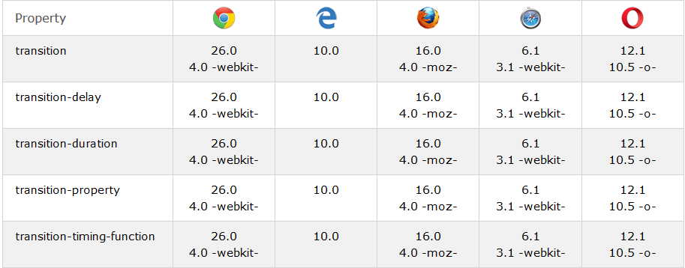

## Specify the Speed Curve of the Transition

The transition-timing-function property specifies the speed curve of the transition effect.

The transition-timing-function property can have the following values:

* ease - specifies a transition effect with a slow start, then fast, then end slowly (this is **default**)
* linear - specifies a transition effect **with the same speed** from start to end
* ease-in - specifies a transition effect with a slow start
* ease-out - specifies a transition effect with a slow end
* ease-in-out - specifies a transition effect with a slow start and end

## Delay the Transition Effect

The transition-delay property specifies a delay (in seconds) for the transition effect.

## CSS3 Transition Properties

The following table lists all the transition properties:

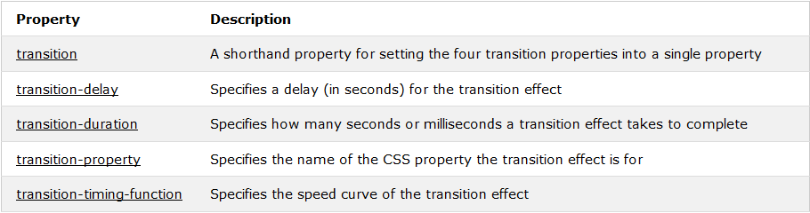

# CSS3 Gradients

CSS3 defines two types of gradients:

* **Linear Gradients (goes down/up/left/right/diagonally)**
* **Radial Gradients (defined by their center)**

## Browser Support

The numbers in the table specify the first browser version that fully supports the property.

Numbers followed by -webkit-, -moz-, or -o- specify the first version that worked with a prefix.

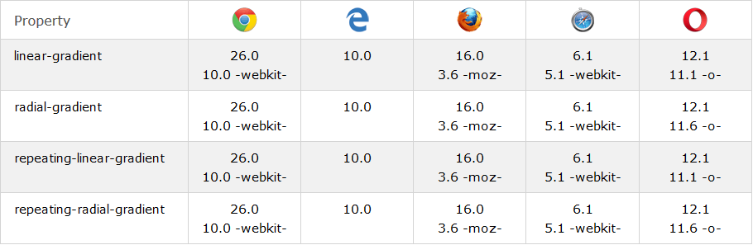

## CSS3 Linear Gradients

To create a linear gradient you must define at least two color stops. Color stops are the colors you want to render smooth transitions among. You can also set a starting point and a direction (or an angle) along with the gradient effect.

### Syntax

background: linear-gradient(direction, color-stop1, color-stop2, ...);

**Linear Gradient - Top to Bottom (this is default)**

#grad {  
    background: red; /* For browsers that do not support gradients */  
    background: -webkit-linear-gradient(red, yellow); /* For Safari 5.1 to 6.0 */  
    background: -o-linear-gradient(red, yellow); /* For Opera 11.1 to 12.0 */  
    background: -moz-linear-gradient(red, yellow); /* For Firefox 3.6 to 15 */  
    background: linear-gradient(red, yellow); /* Standard syntax */  
}

**Linear Gradient - Left to Right**

#grad {  
  background: red; /* For browsers that do not support gradients */  
  background: -webkit-linear-gradient(left, red , yellow); /* For Safari 5.1 to 6.0 */  
  background: -o-linear-gradient(right, red, yellow); /* For Opera 11.1 to 12.0 */  
  background: -moz-linear-gradient(right, red, yellow); /* For Firefox 3.6 to 15 */  
  background: linear-gradient(to right, red , yellow); /* Standard syntax */  
}

**Linear Gradient - Diagonal**

You can make a gradient diagonally by specifying both the horizontal and vertical starting positions.

#grad {  
  background: red; /* For browsers that do not support gradients */  
  background: -webkit-linear-gradient(left top, red, yellow); /* For Safari 5.1 to 6.0 */  
  background: -o-linear-gradient(bottom right, red, yellow); /* For Opera 11.1 to 12.0 */  
  background: -moz-linear-gradient(bottom right, red, yellow); /* For Firefox 3.6 to 15 */  
  background: linear-gradient(to bottom right, red, yellow); /* Standard syntax */  
}

## Using Angles

If you want more control over the direction of the gradient, you can define an angle, instead of the predefined directions (to bottom, to top, to right, to left, to bottom right, etc.).

### Syntax

background: linear-gradient(angle, color-stop1, color-stop2);

#grad {  
  background: red; /* For browsers that do not support gradients */  
  background: -webkit-linear-gradient(-90deg, red, yellow); /* For Safari 5.1 to 6.0 */  
  background: -o-linear-gradient(-90deg, red, yellow); /* For Opera 11.1 to 12.0 */  
  background: -moz-linear-gradient(-90deg, red, yellow); /* For Firefox 3.6 to 15 */  
  background: linear-gradient(-90deg, red, yellow); /* Standard syntax */  
}

## Using Multiple Color Stops

The following example shows a linear gradient (from top to bottom) with multiple color stops:

#grad {  
  background: red; /* For browsers that do not support gradients */  
  background: -webkit-linear-gradient(red, yellow, green); /* For Safari 5.1 to 6.0 */  
  background: -o-linear-gradient(red, yellow, green); /* For Opera 11.1 to 12.0 */  
  background: -moz-linear-gradient(red, yellow, green); /* For Firefox 3.6 to 15 */  
  background: linear-gradient(red, yellow, green); /* Standard syntax */  
}

#grad {  
  background: red; /* For browsers that do not support gradients */  
  background: -webkit-linear-gradient(left,rgba(255,0,0,0),rgba(255,0,0,1)); /*Safari 5.1-6*/  
  background: -o-linear-gradient(right,rgba(255,0,0,0),rgba(255,0,0,1)); /*Opera 11.1-12*/  
  background: -moz-linear-gradient(right,rgba(255,0,0,0),rgba(255,0,0,1)); /*Fx 3.6-15*/  
  background: linear-gradient(to right, rgba(255,0,0,0), rgba(255,0,0,1)); /*Standard*/  
}

# CSS - Cursors

The *cursor* property of CSS allows you to specify the type of cursor that should be displayed to the user.

<div style="cursor:auto">Auto</div>

<div style="cursor:crosshair">Crosshair</div>

<div style="cursor:default">Default</div>

<div style="cursor:pointer">Pointer</div>

<div style="cursor:move">Move</div>

<div style="cursor:e-resize">e-resize</div>

<div style="cursor:ne-resize">ne-resize</div>

<div style="cursor:nw-resize">nw-resize</div>

<div style="cursor:n-resize">n-resize</div>

<div style="cursor:se-resize">se-resize</div>

<div style="cursor:sw-resize">sw-resize</div>

<div style="cursor:s-resize">s-resize</div>

<div style="cursor:w-resize">w-resize</div>

<div style="cursor:text">text</div>

<div style="cursor:wait">wait</div>

<div style="cursor:help">help</div>

# CSS - Visibility

A property called *visibility* allows you to hide an element from view

|  |  |
| --- | --- |
| **Value** | **Description** |
| visible | The box and its contents are shown to the user. |
| hidden | The box and its content are made invisible, although they still affect the layout of the page. |

# CSS - Positioning

CSS helps you to position your HTML element. You can put any HTML element at whatever location you like

## Relative Positioning

Relative positioning changes the position of the HTML element relative to **where it normally appears.**

## Absolute Positioning

An element with **position: absolute** is positioned at the specified coordinates relative to your **screen** top-left corner.

* Move Left - Use a negative value for *left*.
* Move Right - Use a positive value for *left*.
* Move Up - Use a negative value for *top*.
* Move Down - Use a positive value for *top*.

## Fixed Positioning

Fixed positioning allows you to fix the position of an element to a particular spot on the page, regardless of scrolling. Specified coordinates will be relative to the browser window.

# CSS z-index Property

Set the z-index for an image:

img {  
    position: absolute;  
    left: 0px;  
    top: 0px;  
    z-index: -1;  
}

The z-index property specifies the stack order of an element.

An element with greater stack order is always in front of an element with a lower stack order.

**Note:** z-index only works on positioned elements (position:absolute, position:relative, or position:fixed).

# CSS line-height Property

p.small {  
    line-height: 90%;  
}  
  
p.big {  
    line-height: 200%;  
}

## Definition and Usage

The line-height property specifies the line height.

**Note:** Negative values are not allowed.

# CSS text-transform Property

Transform text in different <p> elements:

p.uppercase {  
    text-transform: uppercase;  
}  
  
p.lowercase {  
    text-transform: lowercase;  
}  
  
p.capitalize {  
    text-transform: capitalize;  
}